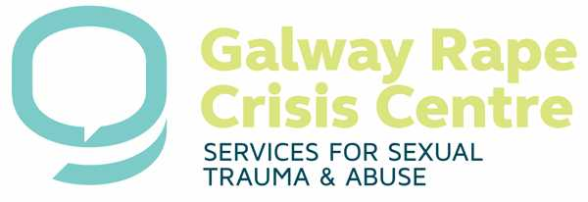
The Lodge, Forster Court, Galway

‘Our aim is to break the silence surrounding sexual abuse and sexual violence in our community by providing a quality counselling and support service as well as working towards an end to cultural and societal tolerance of these issues through lobbying and education.’

SATU Support Worker at GRCC

Information pack

What does the role involve?

- In a multi-disciplinary approach, the Sexual Assault Treatment Unit (SATU) has been providing essential and state of the art services to clients after recent sexual assault in Galway since 2009.

- Services involve medical aftercare, forensic services, as well as emotional and psychological support, the latter provided by GRCC.

- Galway Rape Crisis Centre provide a 365 day a year, 24 hour call out service to the Sexual Assault Treatment Unit (SATU) where our support workers provide much needed psychological support to survivors in the immediate aftermath of a sexual assault/ rape.

- Support workers are on call and respond to call outs as appropriate. (Please note this is not a counselling role.)

What is expected from a Volunteer SATU support worker

- 100% attendance of our 6 weekend training course which provides all training required to support a person in crisis and shock in the aftermath of a sexual assault. Dates will be listed on the application form when the application process is open. Please check them carefully and schedule ahead in your diary if you are considering applying for this role.

- To complete 10 hours of personal therapy whilst training (cost incurred by volunteers). We have arranged a low cost option with some therapists locally.

- A minimum of two years commitment to the service is essential, starting from the end of the shadowing period.

- To be on call for 3 shifts per month chosen by you.

- Shifts to choose from: -Day time shifts- Mon-Sun 9.30 a.m. to 5.30 p.m.
-Night time shifts- Mon-Sun 5.30 p.m. to 9.30 a.m.

- Attend monthly group supervision.

- Role of Roster Manager once in the two year commitment, this requires diverting the telephone to the on call Support Workers.

- Work as part of a team.

- Not to be afraid of the issues we deal with at the centre.

- To support two of our fundraising events, church gate collection in November and Flag day in March

We provide

- Full experiential training. The training includes all the theory required for the position with a strong emphasis on personal development.

- Monthly Supervision (attendance is compulsory)

- Support from the SATU Volunteer Co-ordinator and the centre.

- Out of pocket expenses whilst volunteering.

- The opportunity to be part of a small organisation with dynamic and passionate staff members and volunteers, who provide a much needed service for Galway and surrounding counties.

The selection process involves the following stages:

- Application form
- Interview
- Attendance of one training weekend which is part of the selection process
- Suitable applicants will then be invited to attend the full training
- After attendance of the full training, suitable candidates will complete10 shifts on duty under supervision (‘shadowing’).
- After successful completion of this ‘shadowing’ process, suitable candidates will be invited to join the SATU service and GRCC
- A minimum commitment of 2 years after completion of training (starting from the end of the shadowing process) applies.

